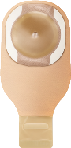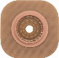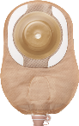
CeraPlus
™
Skin Barrier with Remois Technology
*

More Effective at Protecting Skin from the
Damage of Adhesive Removal
²
,
³
Peristomal Skin: Two Comparative Studies
The Impact of Skin Barriers on
Why These Studies?
We learned from clinicians that skin injuries related to
medical adhesives are prevalent but underreported.
⁴
We think your patients deserve better, and we wanted
to learn more about it.
What is TEWL and Why is it Important to Peristomal Skin?
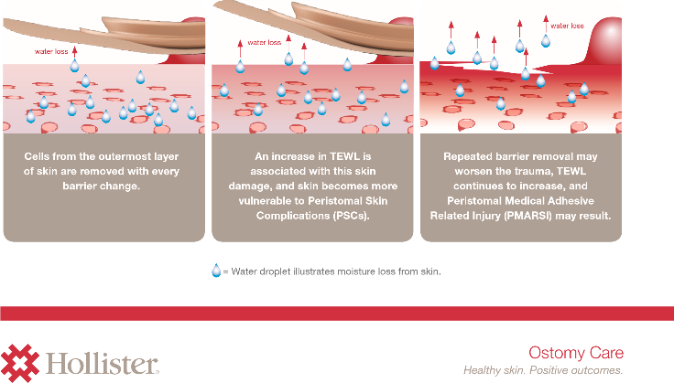
The loss of water through the stratum corneum is called transepidermal water loss (TEWL). Higher rates of TEWL are associated with damaged skin, and ostomy barrier removal can have an impact.^{1,2}
Study #1: Ceramide vs. Manuka Honey and Aloe
Objectives:
Measure skin integrity after ostomy barriers are removed
2 Compare differences in skin integrity with the use of infused skin barriers:
1
- Hollister CeraPlus skin barrier infused with ceramide
- Welland Aurum 2 infused with honey
- Salts Harmony Duo with Flexifit and Aloe

CeraPlus Skin Barrier with Ceramide Significantly Less Disruptive than Welland Aurum 2 with Manuka Honey²
25%

(16.5)
CeraPlus
(42.6)

Aurum 2
0
10
20
30
40
50
Baseline = 5.2
Reported Moisture Loss (on Day 5)
2
Mean TEWL rate | g/m
2
/hr
61
%

lower
TEWL-rate
Baseline = 5.5
of Welland Aurum 2
patients discontinued due to skin problems.* There
were no discontinuations in the CeraPlus group.²
16.5 vs 42.6 g/m2/hour, p<.001 *Of 12 patients using Welland Aurum 2 barrier and Results based on cyberDERM RG-1
Baseline values not statistically different; p=0.214 12 patients using CeraPlus skin barrier computerized evaporimeter
CeraPlus Skin Barrier Better than Harmony Duo with Flexifit and

Aloe at Minimizing Moisture Loss²

(19.2)
CeraPlus
0
10
20
30
40
50
Baseline = 5.8
Reported Moisture Loss (on Day 5)
2
Mean TEW
L rate | g/m
2
/hr
50
%

lower
TEWL-rate
Baseline = 5.6
(38.6)

Harmony Duo
19.2 vs 38.6 g/m2/hour, p<.001 Results based on cyberDERM RG-1
Baseline values not statistically different; p=0.296 computerized evaporimeter

of 12
patients using the aloe
barrier were discontinued due to skin problems.
No ceramide barrier patients were discontinued.²

Study #2: CeraPlus Skin Barrier vs. SenSura Mio
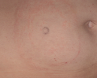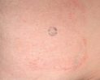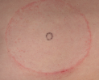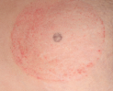
CeraPlus Skin Barrier Better than Sensura Mio at
Minimizing Moisture Loss and Irritation
³
CeraPlus Skin Barrier
Patient A
Patient B
SenSura Mio
Patient A
Patient B
Objectives:
1

Measure skin integrity after ostomy barriers are removed
2

Compare differences in skin integrity between the
Hollister CeraPlus skin barrier
and the
Coloplast SenSura Mio barrier
.
*Measured at most visually traumatized site;
28.5
vs. 16.8, p
=0.003
Baseline values not statistically different; p=0.296
Results based on cyberDERM RG-1 computerized evaporimeter
(16.8)

CeraPlus
20
50
40
30
10
0
Reported Moisture Loss
*,3
Mean TEWL rate
|
g/m
2
/hr
%
41

lower
TEWL-rate
Baseline = 6.5
Baseline = 6.9
(28.5)

SenSura Mio

The Results are Clear: CeraPlus Skin Barrier Helps Ensure Healthy Skin^{2,3}
 | CeraPlus Skin Barrier | Welland Aurum 2 | Salts  Harmony Duo | SenSura Mio
Observed to be better at helping maintain intact skin^{2,3} | ✔ | ✘ | ✘ | ✘
Observed to be better at managing TEWL^{2,3} | ✔ | ✘ | ✘ | ✘
Observed to be better at protecting skin against  damage from repeated barrier removal^{2,3} | ✔ | ✘ | ✘ | ✘
*Remois is a technology of Alcare Co., Ltd.
References:
- Nybaek H, Lophagen S, Karlsmark T, Bang Knudsen D, Jemec GBE. Stratum corneum integrity as a predictor for peristomal skin problems in ostomates. Br J Dermatol. 2010;162:357-361.
- Nichols T, Houser T, Grove G. Comparing the skin stripping effects of three ostomy skin barriers infused with ceramide, honey or aloe Journal of Stomal Therapy Australia 2019; 39(2):14-18
- Grove G, Houser T, Sibbald G, Salvadalena G. Measuring epidermal effects of ostomy skin barriers. Skin Res Technol. 2019;25:179186. https://doi.org/10.1111/srt.12630
Ostomy Care
Healthy skin. Positive outcomes.
- Leblanc K, Whiteley I, McNichol L, Salvadalena G, Gray M. Peristomal Medical Adhesive-Related Skin Injury : Results of an International Consensus Meeting, J Wound Ostomy Continence Nurs 2019; 46 (2):125–136.
Prior to use, be sure to read the package insert for information regarding Intended Use, Contraindications, Warnings, Precautions, and Instructions for Use. The Hollister logo, CeraPlus and “Healthy skin. Positive Outcomes.” are trademarks of Hollister Incorporated. All other trademarks and copyrights are the property of their respective owners. Not all products are CE marked. © 2019 Hollister Incorporated.

